**INTRODUCTION TO JAVA 2**

**1. Create Java classes having suitable attributes for Library management system.Use OOPs concepts in your design.Also try to use interfaces and abstract classes.**

**CODE**

package aayushi;

class Library{

private int lcode;

private String lname;

private String laddress;

Library(int lcode,String lname, String laddress){

this.lcode = lcode;

this.lname = lname;

this.laddress = laddress;

}

}

class Book{

private int bookid;

private String author;

private String bname;

private float price;

Book(int bookid,String author,String bname,float price)

{

this.author = author;

this.bname = bname;

this.bookid = bookid;

this.price =price;

}

}

abstract class MemberRecord {

private int memberID;

private String sname;

private int age;

private int count;

abstract void increaseBookIssue();

abstract void decreseBookIssue();

}

class Student extends MemberRecord{

private String course;

@Override

void increaseBookIssue() {

}

@Override

void decreseBookIssue() {

}

}

class Faculty extends MemberRecord{

private String course;

@Override

void increaseBookIssue() {

}

@Override

void decreseBookIssue() {

}

}

public class Question1 {

public static void main(String[] args) {

Library obj = new Library(1,"CircleLibrary","Delhi");

Library obj1 = new Library(2,"AbcLibrary","Lucknow");

}

}

**2. WAP to sorting string without using string Methods?**

**CODE**

package aayushi;

public class Question2 {

public static void main(String[] args) {

String str = "aayushi";

int j = 0;

char temp = 0;

char[] chars = str.toCharArray();

for (int i = 0; i < chars.length; i++)

{

for (j = 0; j < chars.length; j++)

{

if (chars[j] > chars[i])

{

temp = chars[i];

chars[i] = chars[j];

chars[j] = temp;

}

}

}

for (int i = 0; i < chars.length; i++) {

System.out.println(chars[i]);

}

}

}

**OUTPUT**

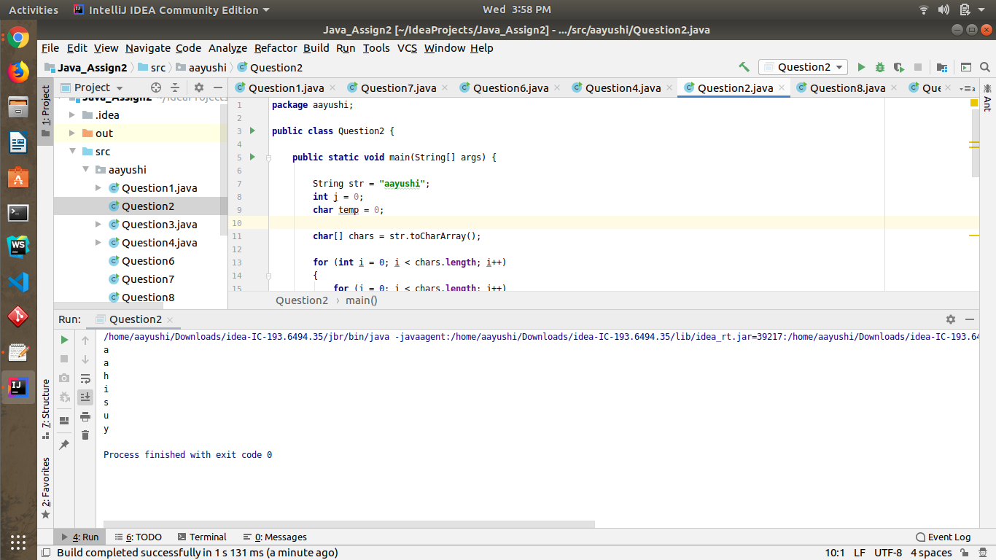

**3. WAP to produce NoClassDefFoundError and ClassNotFoundException exception.**

**A.ClassNotFoundException :**ClassNotFoundException occurs when you try to load a class at runtime using Class.forName() or loadClass() methods and requested classes are not found in classpath.

**CODE**

package aayushi;

public class Question3 {

public static void main(String[] args) {

try

{

Class.forName("Aayushi_test");

}

catch (ClassNotFoundException ex)

{

ex.printStackTrace();

}

}

}

**OUTPUT**

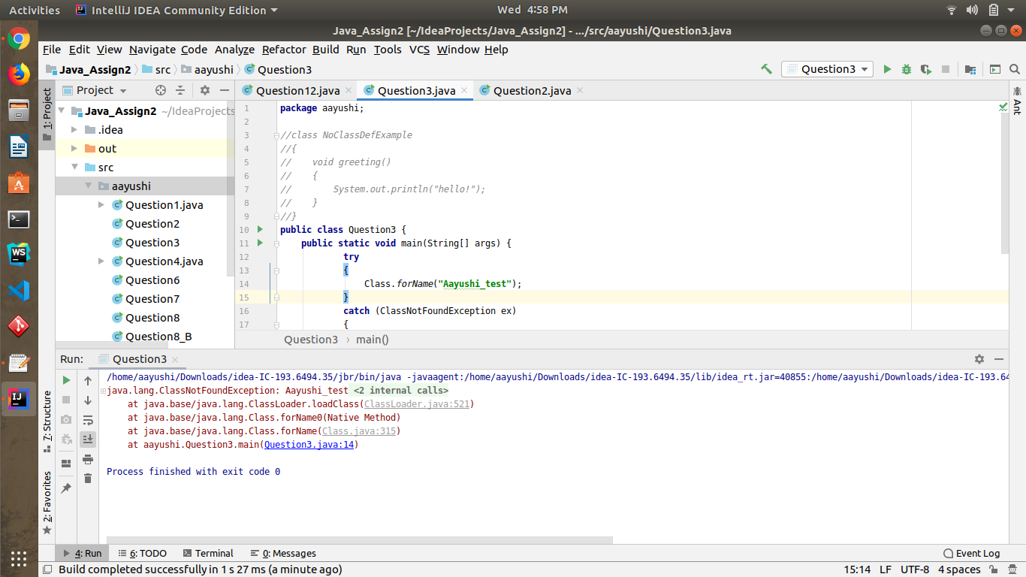

**B. NoClassDefFoundError** :NoClassDefFoundError occurs when class was present during compile time and program was compiled and linked successfully but class was not present during runtime.

**CODE**

package aayushi;

// Java program to illustrate

// NoClassDefFoundError

class ExceptionExample {

public void print(){

System.out.println("Hello");

}

}

public class Question3 {

public static void main(String[] args) {

ExceptionExample e = new ExceptionExample();

e.print();

}

}

**OUTPUT**

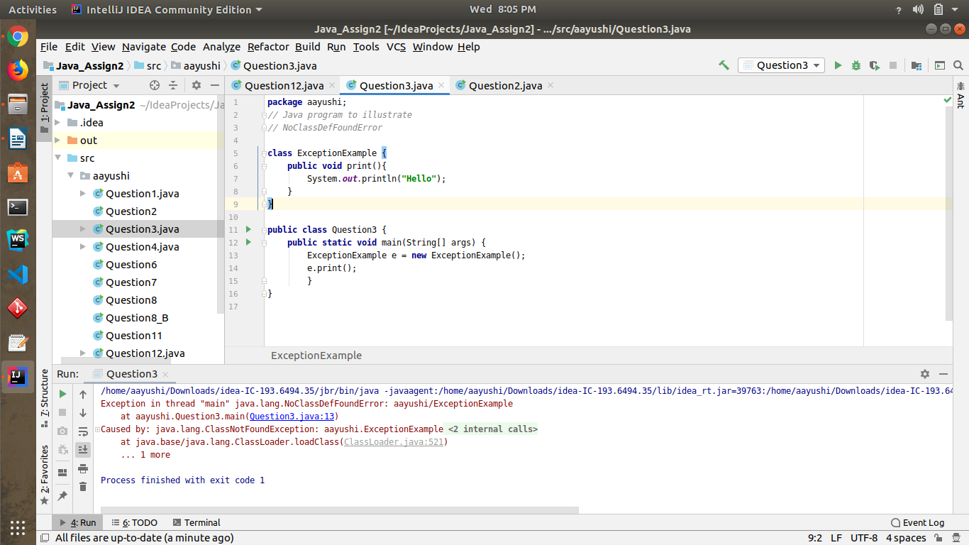

**4. WAP to create a singleton class.**

**CODE**

package aayushi;

class Singleton

{

private static Singleton single_instance = null; // static variable single_instance of type Singleton

public String s;

private Singleton() // private constructor restricted to this class itself

{

s = "Private constructor of Singleton class";

}

public static Singleton getInstance() // static method to create instance of Singleton class

{

if (single_instance == null)

single_instance = new Singleton();

return single_instance;

}

}

public class Question4 {

public static void main(String[] args) {

Singleton x = Singleton.getInstance(); // instantiating Singleton class with variable x

Singleton y = Singleton.getInstance();

Singleton z = Singleton.getInstance();

x.s = (x.s).toUpperCase(); // changing variable of instance x

System.out.println("String from x is " + x.s);

System.out.println("String from y is " + y.s);

System.out.println("String from z is " + z.s);

System.out.println("\n");

}

}

**OUTPUT**

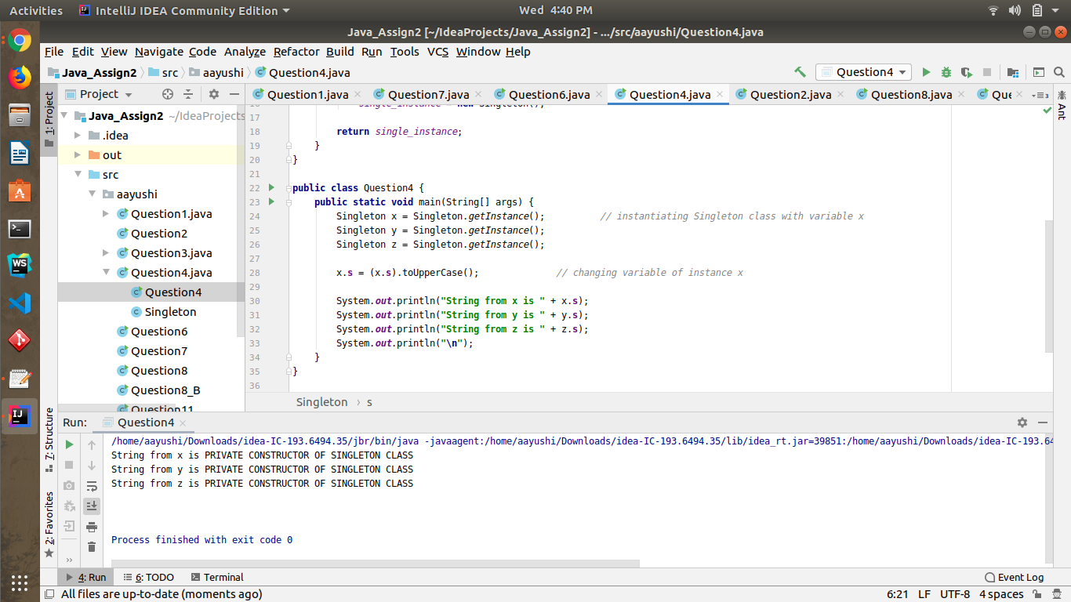

**5. WAP to show object cloning in java using cloneable and copy constructor both.**

**CODE**

package aayushi;

import java.lang.Cloneable;

//WAP to show object cloning in java using cloneable and copy constructor both.

public class Question5 implements Cloneable{

int number;

String str;

Question5(int number , String str){

this.number = number;

this.str= str;

}

Question5(Question5 obj){

System.out.println("Copy Constructor called!!!");

number= obj.number;

str= obj.str;

}

public Object clone()throws CloneNotSupportedException{

System.out.println("Clone function Called !!!");

return super.clone();

}

public static void main(String[] args) throws CloneNotSupportedException {

try{

Question5 originalObject1 = new Question5(1,"Aayushi");

System.out.println(originalObject1.number+" " + originalObject1.str);

Question5 cloneableObject2 = (Question5) originalObject1.clone();

System.out.println(cloneableObject2.number+" " + cloneableObject2.str);

Question5 copyConstructorObject3 =new Question5(originalObject1);

System.out.println(copyConstructorObject3.number+" " + copyConstructorObject3.str);

}

catch (CloneNotSupportedException cnse){}

}

}

**OUTPUT**

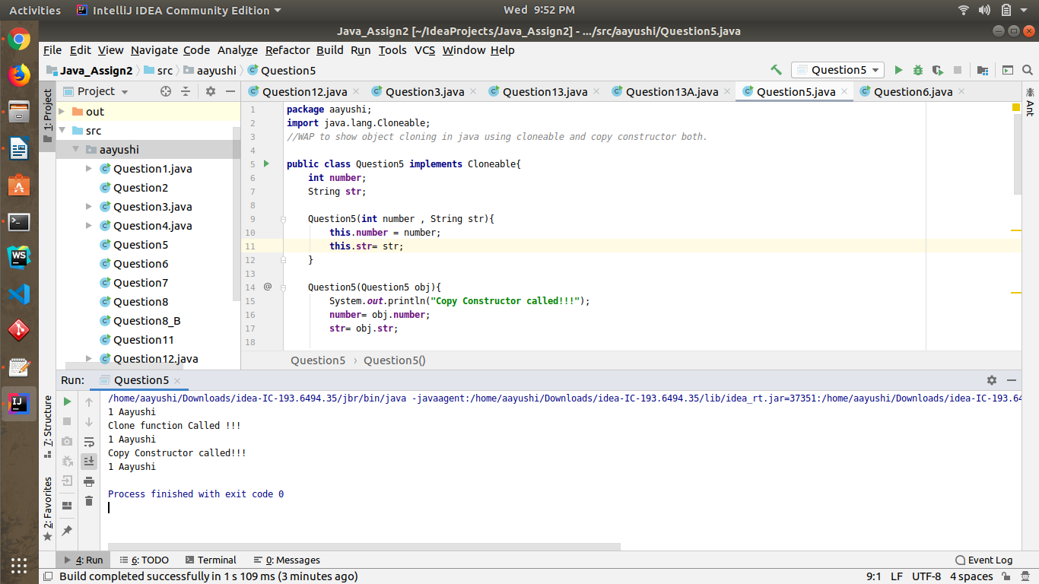

**6. WAP showing try, multi-catch and finally blocks.**

**CODE**

package aayushi;

import java.util.Scanner;

//6. WAP showing try, multi-catch and finally blocks.

public class Question6 {

public static void main(String[] args) {

System.out.println("Enter two numbers:");

Scanner sc = new Scanner(System.in);

try

{

int n = sc.nextInt();

int n1 = sc.nextInt();

int res = n/n1;

System.out.println("The division is:"+res);

}

catch(ArithmeticException ex)

{

System.out.println("Arithmetic Exception"); // This exception occurs when an integer is divided by zero.

}

catch(NumberFormatException ex) //unable to format (convert) a string into a number.

{

System.out.println("Number Format Exception");

}

catch(Exception ex)

{

System.out.println(ex.getStackTrace());

}

finally {

System.out.println("This finally block of code is always executed");

}

System.out.println("This statement is executed if the exception is handled");

}

}

**OUTPUT**

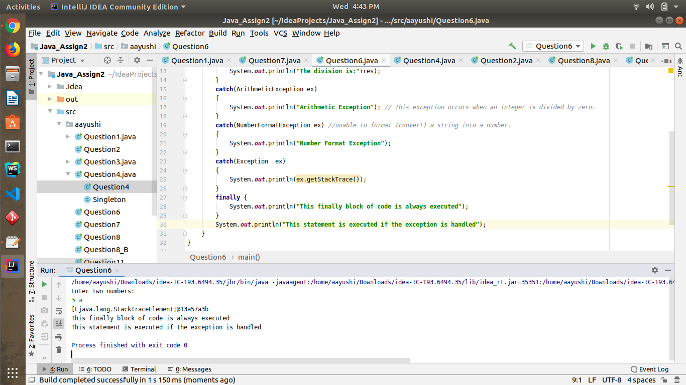

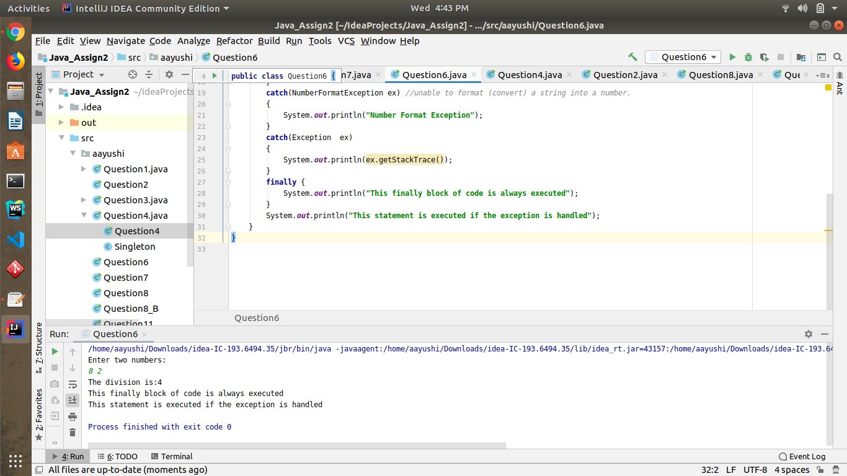

**7. WAP to convert seconds into days, hours, minutes and seconds.**

**CODE**

package aayushi;

import java.util.Scanner;

//7. WAP to convert seconds into days, hours, minutes and seconds.

public class Question7 {

public static void main(String[] args) {

Scanner sc = new Scanner(System.in);

System.out.println("Enter the seconds: ");

int n = sc.nextInt();

int days = n / (24*3600);

n = n % (24*3600);

int hour = n / 3600;

n = n % 3600;

int min = n / 60;

n = n % 60;

System.out.println("The days:"+days);

System.out.println("The hours:"+hour);

System.out.println("The minutes:"+min);

System.out.println("The seconds:"+n);

}

}

**OUTPUT**

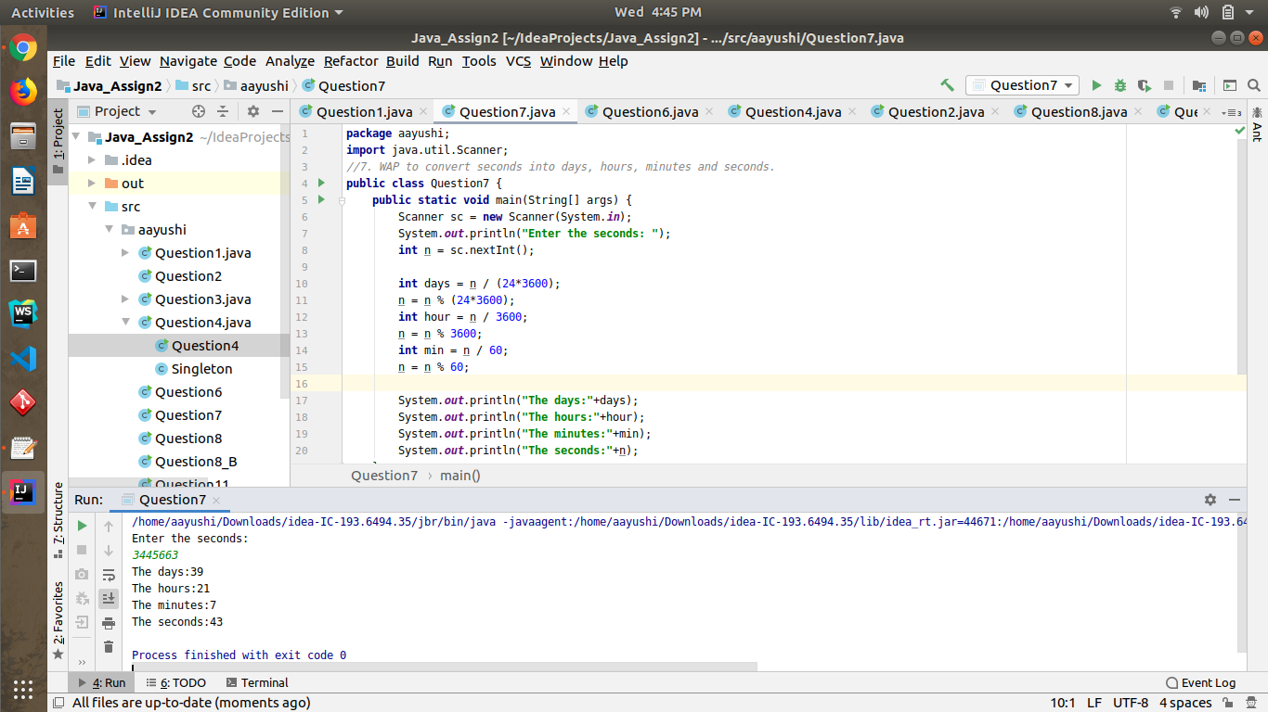

**8. WAP to read words from the keyboard until the word done is entered. For each word except done, report whether its first character is equal to its last character. For the required loop, use a**

**a)while statement**

**CODE**

package aayushi;

import java.util.Scanner;

public class Question8 {

public static void main(String[] args) {

Scanner keyboard = new Scanner(System.in);

System.out.println("Please Enter A word: ");

String word = keyboard.next();

while(!word.equals("done"))

{

if(word.charAt(0) == word.charAt(word.length() - 1))

System.out.println("First and last character are equals for the word: " + word);

else

System.out.println("First and last character are NOT equals for the word: " + word);

word = keyboard.next();

}

}

}

**OUTPUT**

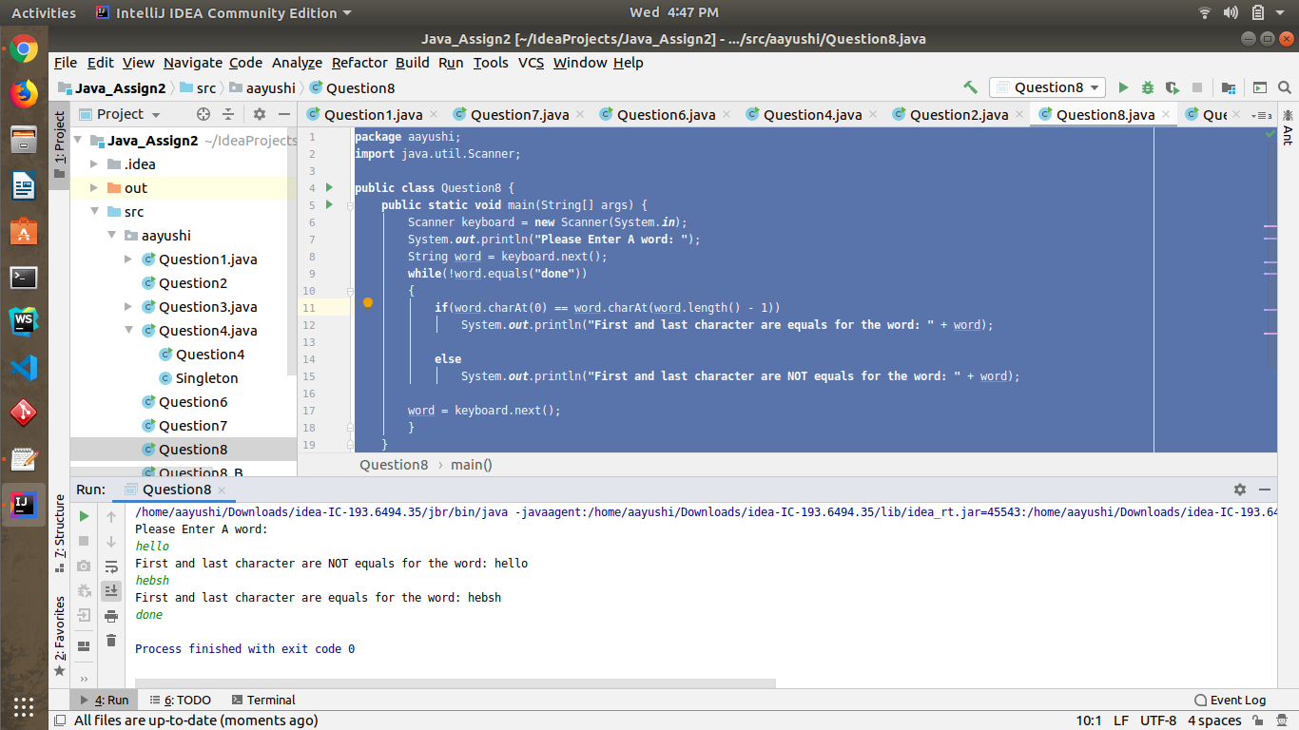

**b)do-while statement**

**CODE**

package aayushi;

import java.util.Scanner;

public class Question8_B {

public static void main(String[] args) {

Scanner keyboard = new Scanner(System.in);

System.out.println("Enter a word");

String word = keyboard.next();

do

{

if(word.charAt(0) == word.charAt(word.length() - 1))

{

System.out.println("First and last character are equals for the word: " + word);

}

else

{

System.out.println("First and last character are NOT equals for the word: " + word);

}

word = keyboard.next(); }

while(!word.equals("done"));

}

}

**OUTPUT**

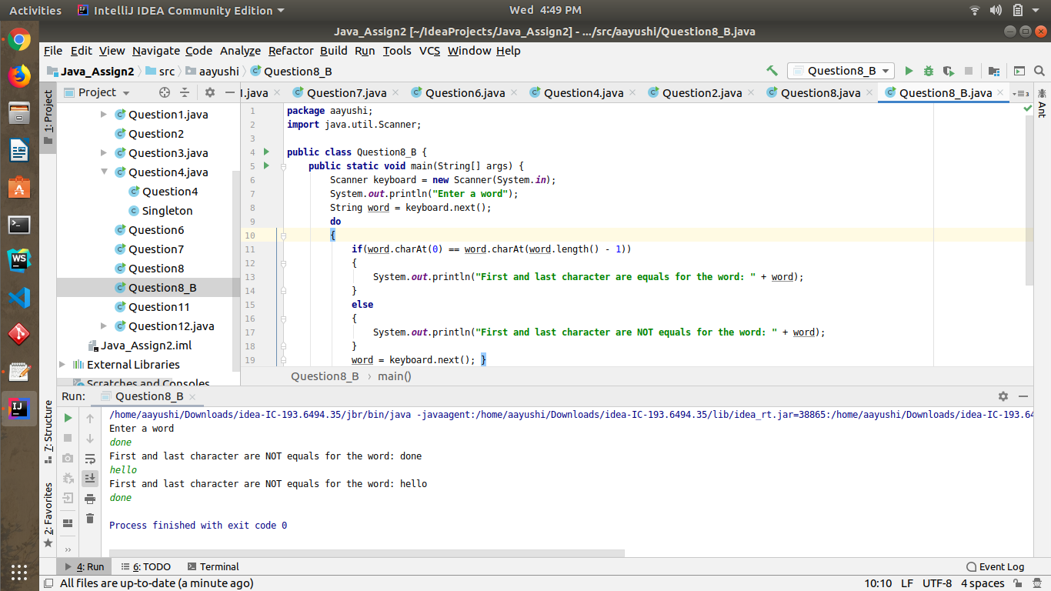

**9. Design classes having attributes for furniture where there are wooden chairs and tables, metal chairs and tables. There are stress and fire tests for each products.**

**CODE**

package aayushi;

public class Ques9 {

public static void main(String[] args) {

Chair woodenChair = new Chair("Godrej Interio",1300,"wooden");

Chair metalChair = new Chair("Style Spa",3200,"metal");

Table woodenTable = new Table("Godrej Interio",2400,"wooden");

Table metalTable = new Table("Style Spas",5700,"metal");

System.out.println("Details of Wooden Chair-------------------------------");

System.out.println(woodenChair.manufacturer);

System.out.println(woodenChair.price);

System.out.println(woodenChair.type);

System.out.println(woodenChair.fireTest());

System.out.println(woodenChair.stessTest());

System.out.println("Details of Metal Chair-------------------------------");

System.out.println(metalChair.manufacturer);

System.out.println(metalChair.price);

System.out.println(metalChair.type);

System.out.println(metalChair.fireTest());

System.out.println(metalChair.stessTest());

System.out.println("Details of Wooden Table-------------------------------");

System.out.println(woodenTable.manufacturer);

System.out.println(woodenTable.price);

System.out.println(woodenTable.type);

System.out.println(woodenTable.fireTest());

System.out.println(woodenTable.stessTest());

System.out.println("Details of Metal Table-------------------------------");

System.out.println(metalTable.manufacturer);

System.out.println(metalTable.price);

System.out.println(metalTable.type);

System.out.println(metalTable.fireTest());

System.out.println(metalTable.stessTest());

}

}

class Furniture{

String manufacturer;

float price;

Furniture(String manufacturer, float price){

this.manufacturer = manufacturer;

this.price = price;

}

public String stessTest(){

return "Stress Test Passed";

}

public String fireTest(){

return "Fire Test Passed";

}

}

class Chair extends Furniture{

String type ;

Chair(String manufacturer, float price, String type){

super(manufacturer,price);

this.type = type;

}

}

class Table extends Furniture{

String type ;

Table(String manufacturer, float price, String type){

super(manufacturer,price);

this.type = type;

}

}

**OUTPUT**

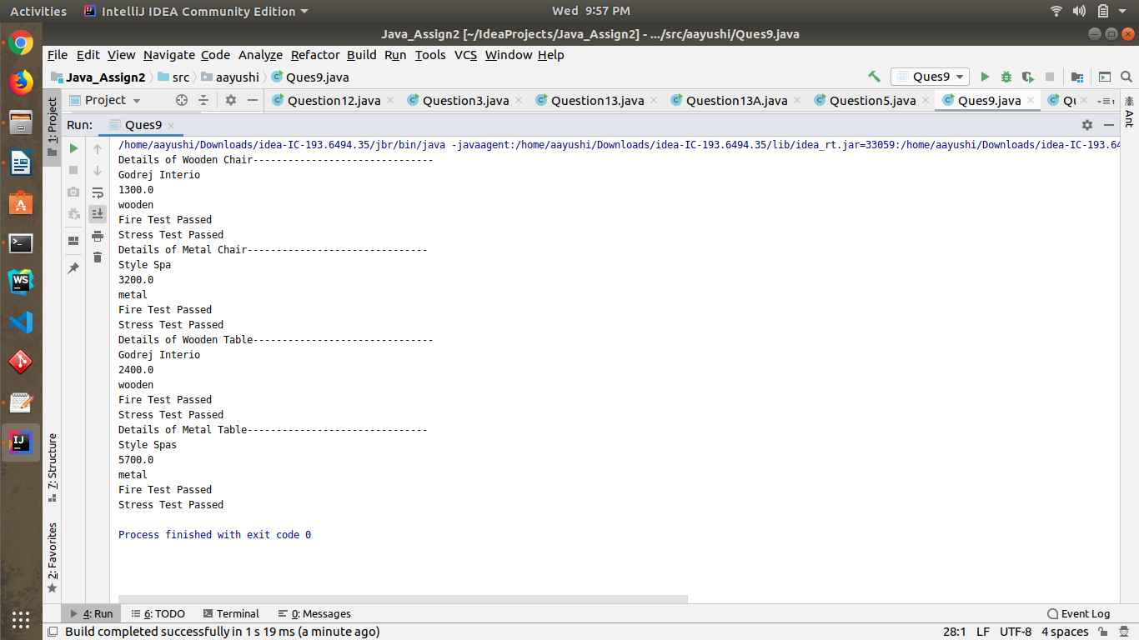

**10. Design classes having attributes and method(only skeleton) for a coffee shop. There are three different actors in our scenario i.e * Customer, Cashier,Barista.**

**11. Convert the following code so that it uses nested while statements instead of for statements.**

**int s = 0;**

**int t = 1;**

**for (int i = 0; i < 10; i++)**

**{**

**s = s + i;**

**for (int j = i; j > 0; j−−)**

**{**

**t = t * (j - i);**

**}**

**s = s * t;**

**System.out.println("T is " + t);**

**}**

**System.out.println("S is " + s);**

**CODE**

package aayushi;

public class Question11 {

public static void main(String[] args) {

int s = 0;

int t = 1;

int i=0;

int j;

while(i < 10)

{

s = s + i;

j = i;

while(j > 0)

{

t = t * (j - i);

j--;

}

s = s * t;

System.out.println("T is " + t);

i++;

}

System.out.println("S is " + s);

}

}

**OUTPUT**

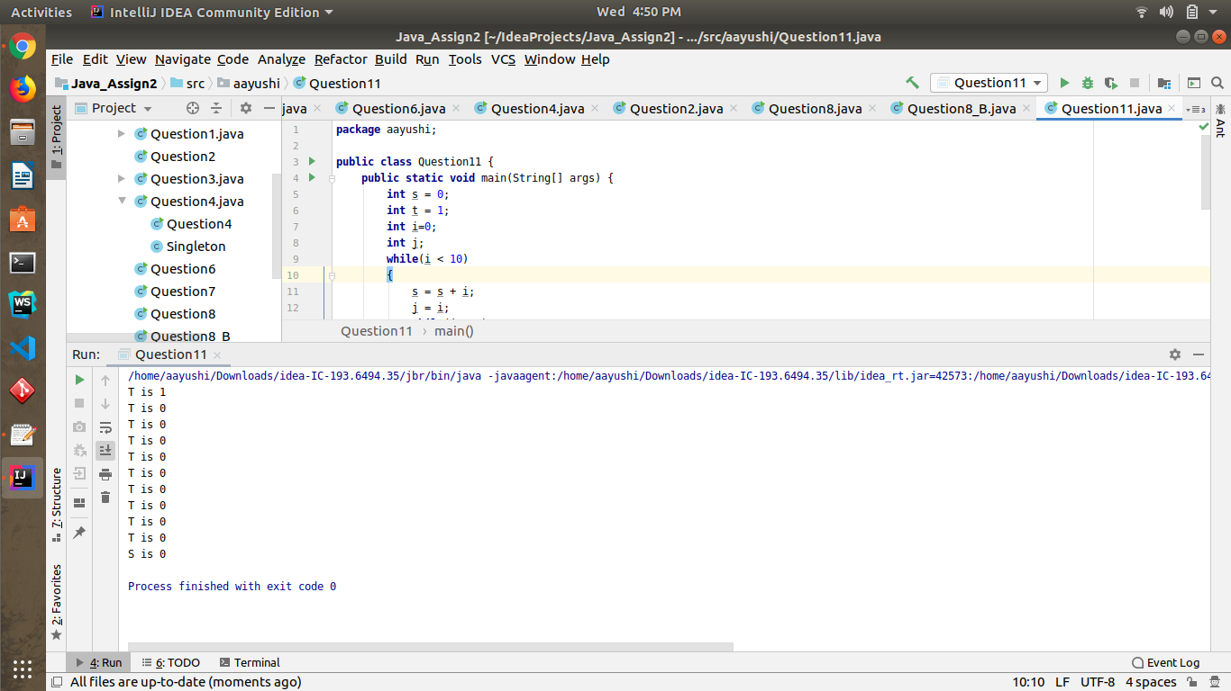

**12.What will be the output on new Child(); ?**

**CODE**

package aayushi;

class Parent extends Grandparent {

{

System.out.println("instance - parent");

}

public Parent() {

System.out.println("constructor - parent");

}

static {

System.out.println("static - parent");

}

}

class Grandparent {

static {

System.out.println("static - grandparent");

}

{

System.out.println("instance - grandparent");

}

public Grandparent() {

System.out.println("constructor - grandparent");

}

}

class Child extends Parent {

public Child() {

System.out.println("constructor - child");

}

static {

System.out.println("static - child");

}

{

System.out.println("instance - child");

}

}

public class Question12 {

public static void main(String[] args) {

new Child();

}

}

**OUTPUT**

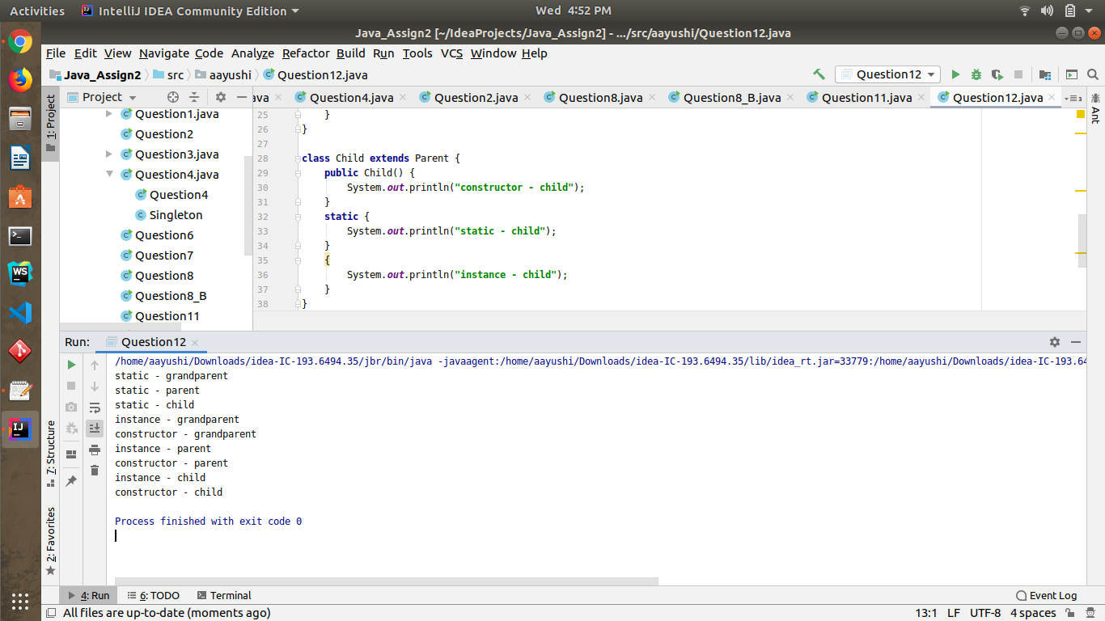

**13. Create a custom exception that do not have any stack trace.**

**CODE**

package aayushi;

import java.util.Scanner;

//Create a custom exception that do not have any stack trace.

public class Question13A {

public static void main(String[] args) throws HandMadeException {

Scanner sc = new Scanner(System.in);

try {

System.out.println("Press Enter to throw Exception");

sc.nextLine();

throw new HandMadeException("This is a Custom Exception");

}

catch (HandMadeException hme){

System.out.println(hme.getMessage());

System.out.println(hme.getStackTrace());

}

}

}

class HandMadeException extends Exception{

public HandMadeException(String message){

super(message);

}

}

**OUTPUT**

